**Section 2: Initial Experimentation on pre-recorded EEG dataset for EEG-based biometrics (9/7/2021 - 10/27/2021)**

* **Explored the EEG dataset**
* **Designed a 4-layer neural network to train initial model**
* **Applied third-party libraries, including XGBoost and LazyPredict for further model training.**
* **Evaluated these models using confusion matrix**

**Conclusion: We need to enhance data preprocessing**

**9/14/2021:**

Loaded the BED dataset that we got access to. Decided to use the RC Stimulus as it is the most natural condition of resting and closing your eyes. Plotted the provided raw data. Focused on training an initial model. Tried a 4-layer neural network.

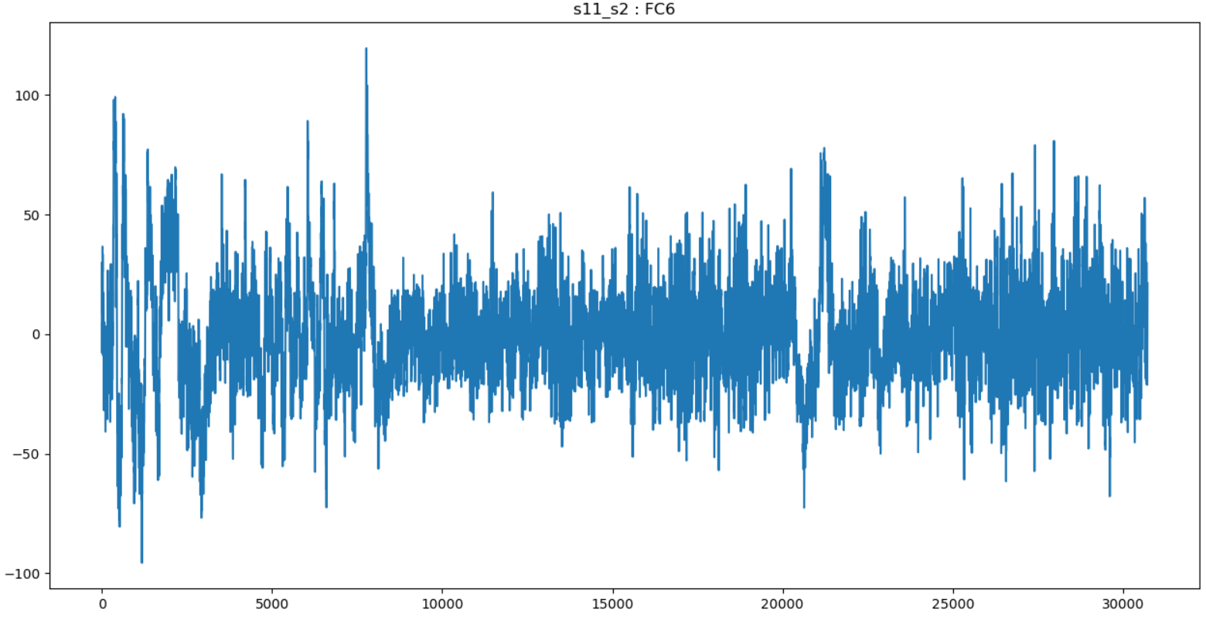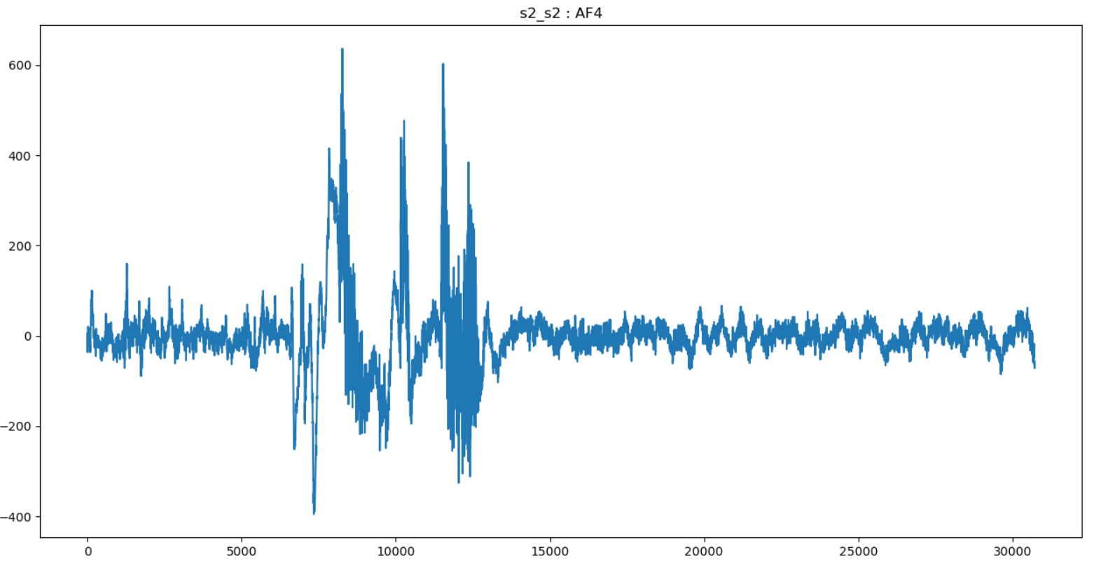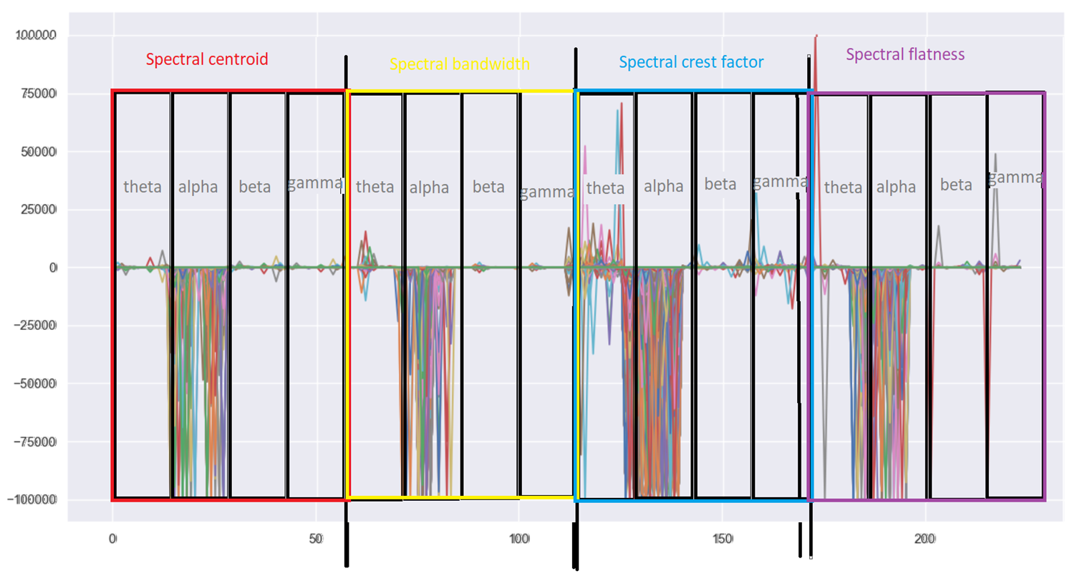

**9/19/2021:**

Trained a 4-layer neural network on the SPEC features of the RC Stimulus of the BED dataset. Results: accuracy: 18.7%, recall: 17.3%, precision: 17.6%, f1 score: 14.3% The BED paper had an accuracy of 37.9%. Decided to see if there is any code that I can run to get familiar with EEG data.

**9/21/2021:**

Talked to Khuong Vo about trying other people’s code. Found these projects: [PSI](https://github.com/ziyujia/Physiological-Signal-Classification-Papers#eeg), [Deep Learning for BCI](https://github.com/xiangzhang1015/Deep-Learning-for-BCI)

**9/23/2021:**

Talked to Khuong Vo. Decided to try the XGBoost Model as it is a very powerful algorithm.

**9/29/2021:**

Tried the XGBoost Model. Results: accuracy: 40.27%, precision: 33.91%, recall: 38.08%, f1 score: 33.46%

**10/01/2021:**

Talked to Khuong Vo about the 4-layer neural network model and XGBoost model I trained.

Conclusions:

* Try the relu activation function instead of the sigmoid activation function, because this would avoid the exploding gradients. Try different layers, standardizations, and hidden units.
* Standardize the data before using it as input for training the neural network as this will make sure that all your data is consistent and easy to use, when the model gets trained on it.
* Use the new Weights and Biases (W&B) module to track the training process, so I can visualize how the weights and biases change and their respective gradients throughout the entire training process.

**10/19/2021:**

Ran other EEG projects to see how they preprocessed and trained a model on the EEG data. (DL-EEG, PhysioNet)

**10/24/2021:**

Ran a mTBI project that also used EEG signals. Plotted the data. Visualized how the data was preprocessed as the data was split into epochs and had their artifacts removed.

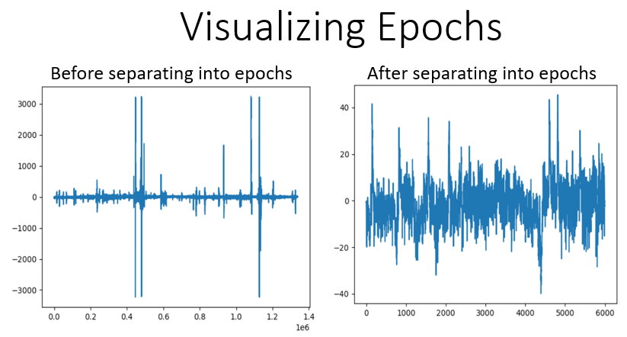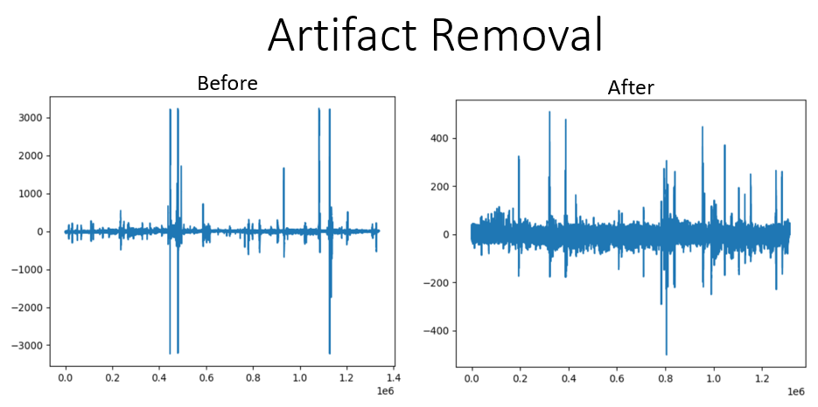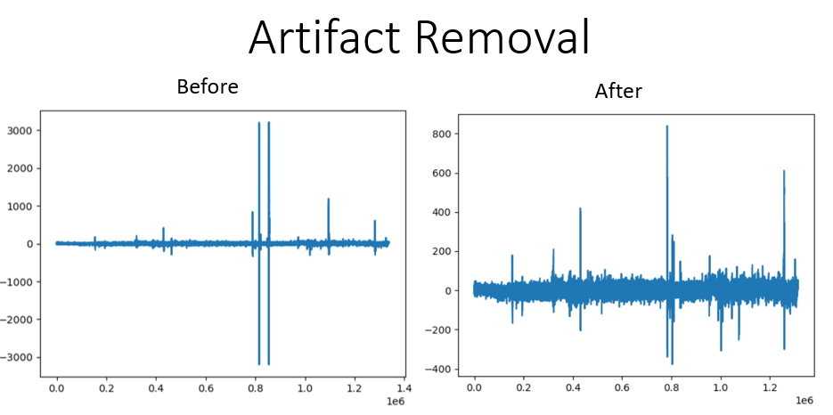

**10/26/2021:**

Improved the 4-layer neural network. Results: accuracy: 38.31%, precision:32.54%, recall: 36.17%, f1 score: 31.86%

**10/27/2021:**

Talked to Khuong Vo about my current progress. Decided to use the LazyPredict package to see the performance of other models like KNN, decision trees, K-mean. Decided to also plot the EEG data also in the frequency domain as signals are much easier to decipher in the frequency domain then in the time domain.